ATTACHMENT 3 – Proposed concept subdivision including approximately 1200 residential lots

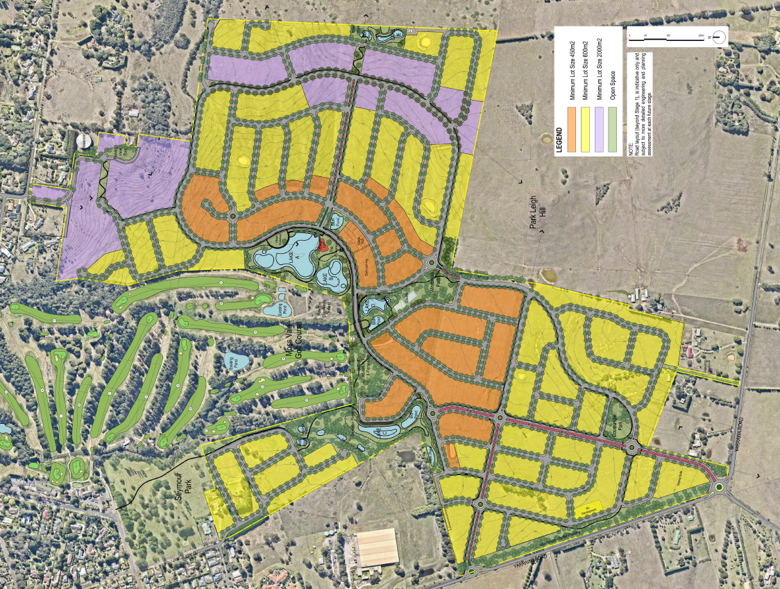
Proposed concept subdivision including approximately 1200 residential lots

